PRACTICE PAPER -2
1) Write the Tags to create Headings in HTML
<h1></h1> <!-- Largest Heading -->
<h2></h2>
<h3></h3>
<h4></h4>
<h5></h5>
<h6></h6> <!-- Smallest Heading -->
2) How to apply external CSS?
<link rel="stylesheet" type="text/css" href="styles.css">
- This tag is placed inside the `<head>` section of an HTML document.
3) What is padding in CSS?
- Padding is the space between the content of an element and its border. It creates inner space within an element.
4) What are Block Level Elements?
- Ans: Block-level elements are elements that take up the full width of their parent container, forcing a line break before and after them. Examples include:
- `<div>`
- `<p>`
- `<h1>` to `<h6>`
- `<section>`, `<article>`
5) Are Headings Block Level Elements?
- Ans: Yes.
6. write the html code to develop below application with headings
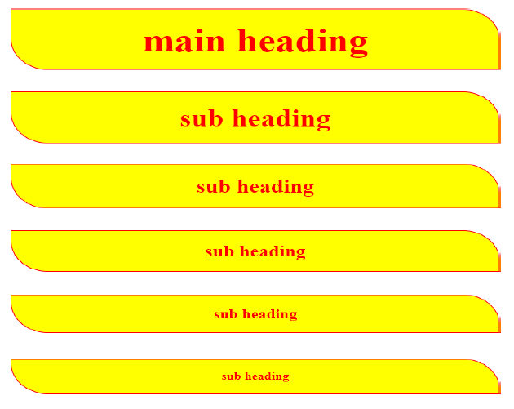

<html>
<head>
<title>Headings</title>
<link rel="stylesheet" href="headings.css">
</head>
<body>
<h1>main heading </h1>
<h2>sub heading</h2>
<h3>sub heading</h3>
<h4>sub heading</h4>
<h5>sub heading</h5>
<h6>sub heading</h6>
</body>
</html>

headings.css
h1,h2,h3,h4,h5,h6{
color: red;
background-color: yellow;
text-align: center;
padding: 20px;
border: 1px solid red;
width: 50%;
border-radius: 0px 60px;
box-shadow: 0px 0px 20px red;
}
Out put :

